

**College of Software, Jilin University**

**Course Report of**

**Software Architecture, 2023**

**Title:** Architecture design for a XR technique based personal information management system

**Date：** 2022/10/13

**Team No.:** Team 27

**Members:**

|  |  |  |  |  |
| --- | --- | --- | --- | --- |
| **序号** | **学号** | **姓名** | **贡献**  **百分比** | **手写电子签名** |
| 1 | 55210425 | 朱家顺 | 29 | IMG_256 |
| 2 | 55210423 | 苏沛泽 | 26 | IMG_257 |
| 3 | 55210424 | 翟启发 | 24 | IMG_258 |
| 4 | 55210422 | 张长兴 | 21 | IMG_259 |

**Content**

[Ⅰ. INTRODUCTION 2](#_Toc28025)

[1.1 Antecedent knowledge 2](#_Toc4898)

[1.1.1 Xerox Radiography(XR) 2](#_Toc24761)

[Ⅱ.ARCHITECTURAL REPRESENTATION 2](#_Toc28525)

[Ⅲ.ARCHITECTURAL GOALS AND CONSTRAINTS 3](#_Toc861)

[3.1 Goals 3](#_Toc21530)

[3.2 Constraints 3](#_Toc5672)

[3.2.1 Technical constraints 3](#_Toc25948)

[3.2.2 User constraints 4](#_Toc24860)

[Ⅳ.USE-CASE VIEW: ARCHITECTURALLY-SIGNIFICANT USE CASE 4](#_Toc30069)

[4.1 Use Case for Visitor 4](#_Toc5775)

[4.1.1 Log in 4](#_Toc31229)

[4.2 Use Case for User 5](#_Toc6128)

[4.2.1 Register a personal account 5](#_Toc20501)

[4.2.2 View personial information 6](#_Toc29082)

[4.2.3 Modify personal information 7](#_Toc28515)

[4.3 Use Case for Teacher 7](#_Toc20075)

[4.3.1 View students' information 7](#_Toc27094)

[4.4 Use Case for Administrator 8](#_Toc26881)

[4.4.1 Modify user’s information 8](#_Toc18033)

[4.4.2 View people’s information 8](#_Toc28601)

[4.4.3 Create accounts for users 9](#_Toc30659)

[Ⅴ.LOGICAL VIEW: ARCHITECTURE OVERVIEW 10](#_Toc14835)

[5.1 Class Diagram 10](#_Toc29352)

[5.2 Database Construction 11](#_Toc24614)

[5.2.1 Entity Relationship Diagram 11](#_Toc20618)

[5.2.2 Relational schema 11](#_Toc5563)

[Ⅵ.PROCESS VIEW 11](#_Toc62)

[6.1 Activity Diagram 11](#_Toc23263)

[Ⅷ.DEPLOYMENT VIEW 13](#_Toc25389)

[7.1 Deployment Diagram 13](#_Toc3486)

[Ⅸ.PHYSICAL VIEW 14](#_Toc24688)

[8.1 Component Diagram 14](#_Toc23805)

[Ⅹ.REFERENCES 14](#_Toc1531)

## Ⅰ. INTRODUCTION

## Antecedent knowledge

* + 1. **Xerox Radiography(XR)**

XR technology refers to the combination of real and virtual through computers to create a virtual environment for human-computer interaction, and is a collective term for a variety of technologies such as VR (Virtual Reality), AR (Augmented Reality), MR (Mixed Reality), etc. XR technology can be applied to a variety of fields, such as education XR technology can be applied in many fields, such as education, entertainment, healthcare, industry, etc., to provide users with immersive experiences and innovative services.

* + 1. **Personal Information Management System**

A personal information management system (PIMS) is a software tool that helps users manage their personal information throughout the entire process, from generating and acquiring it, classifying and recording it, maintaining and changing it, and analysing and using it. A personal information management system can cover a wide range of information such as calendars, contacts, tasks, notes, emails, passwords, etc., so that users can easily organise and manage their lives and work.

A personal information management system based on XR technology is one that uses XR technology to provide a virtual information management platform for users to view and manipulate their personal information in a virtual environment through devices such as head-mounted devices or smartphones. Such a system can improve the efficiency of users' information acquisition and processing, and also increase their fun and participation.

## Ⅱ.ARCHITECTURAL REPRESENTATION

This document uses UML to show, build and document all the artefacts covered in this document. This document uses the innovative 4+1 view format to present different aspects of the system: use case view, logical view, process view, deployment view, and physical view. Each part uses multiple graphs to show its detailed functionality and a model + text description format to present the goals, potential requirements, functional requirements, deployment design, and other aspects of the system.

## Ⅲ.ARCHITECTURAL GOALS AND CONSTRAINTS

## 3.1 Goals

Create a highly immersive and interactive virtual information management platform that takes advantage of XR technology to improve users' information acquisition and processing efficiency and increase their enjoyment and engagement. To achieve this goal, the system design should provide a rich and friendly user interface that supports multiple interaction methods, such as gesture, voice, and eye movement, as well as multiple information presentation methods, such as 2D, 3D, and panorama.

Design a flexible and scalable software architecture that supports multiple types and formats of personal information, as well as access and collaboration with multiple XR devices and cloud services. To achieve this, the system design should use a modular, layered, service-oriented architecture to facilitate system maintenance and updates. The system design should use uniform and standard data formats and interfaces to facilitate data conversion and exchange.

Implement a secure and reliable software architecture that protects users' personal information and privacy, prevents data loss or leakage, and provides data backup and recovery functions. To achieve this goal, the system design should employ encryption, authentication, authorisation and auditing technologies to enhance system security. The system design should employ techniques such as logging, monitoring, testing, and debugging to enhance the maintainability of the system.

## 3.2 Constraints

### 3.2.1 Technical constraints

The development level and maturity of XR technology. Your system design needs to consider some of the current technical bottlenecks and challenges of XR technology, such as device cost, user experience, network transmission, rendering processing, content production, etc.

Compatibility and interoperability of XR devices. Your system design needs to consider how to adapt to the hardware characteristics, software platforms, network protocols, data formats, etc. of different XR devices to achieve compatibility and interoperability between devices. You need to consider how to choose appropriate XR device standards and specifications, how to design unified and standardized data interfaces and exchange protocols, and how to achieve discovery, connection, synchronization, and collaboration between devices.

### 3.2.2 User constraints

The application scenarios and requirements of XR technology. Your system design needs to consider the application scenarios and requirements of XR technology, which will affect the functionality, interface, and interaction mode of your system design. You need to consider who your target users are, what information management services they need, what environment and context they will use your system in, and what expectations and requirements they have for system performance and security.

## Ⅳ.USE-CASE VIEW: ARCHITECTURALLY-SIGNIFICANT USE CASE

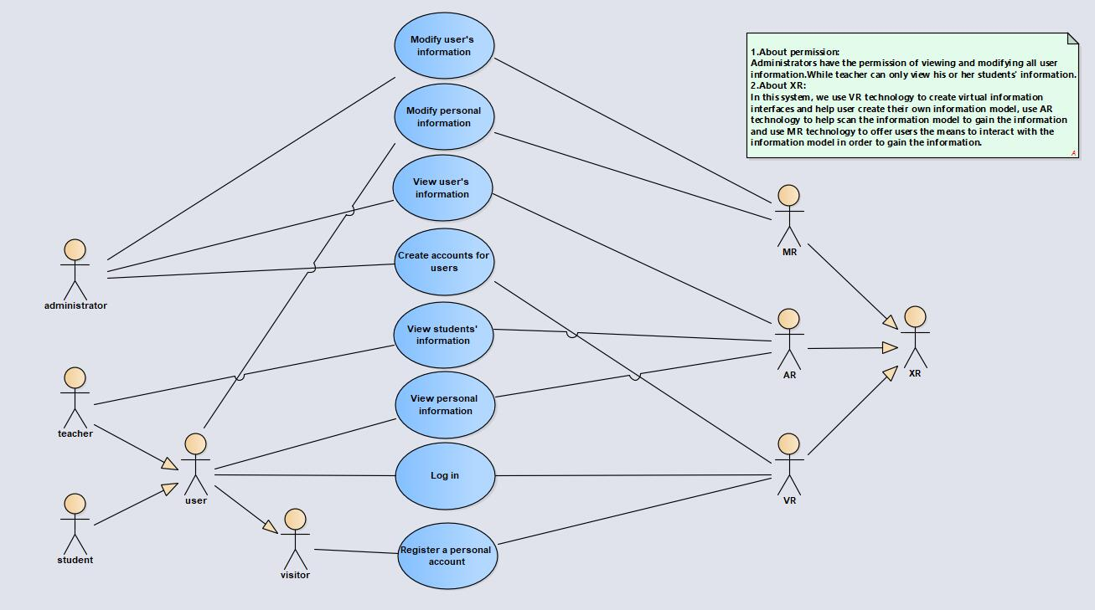

Fig 1

## 4.1 Use Case for Visitor

### 4.1.1 Log in

Use Case：Log in

Participant：User

Brief description：In this use case, users can log in using virtual reality technology.

Main flow:

1. The user enters the virtual reality system and selects the login option.
2. The system displays the virtual keyboard and input box.
3. User enters account and password.
4. The virtual reality system sends the information to the login system for judgment.
5. The login system returns the results to the user through the virtual reality system.

Alternative flow：

* 1. The login system determines that the account password is incorrect, and the virtual reality system displays the result.
  2. User re-enters account password.

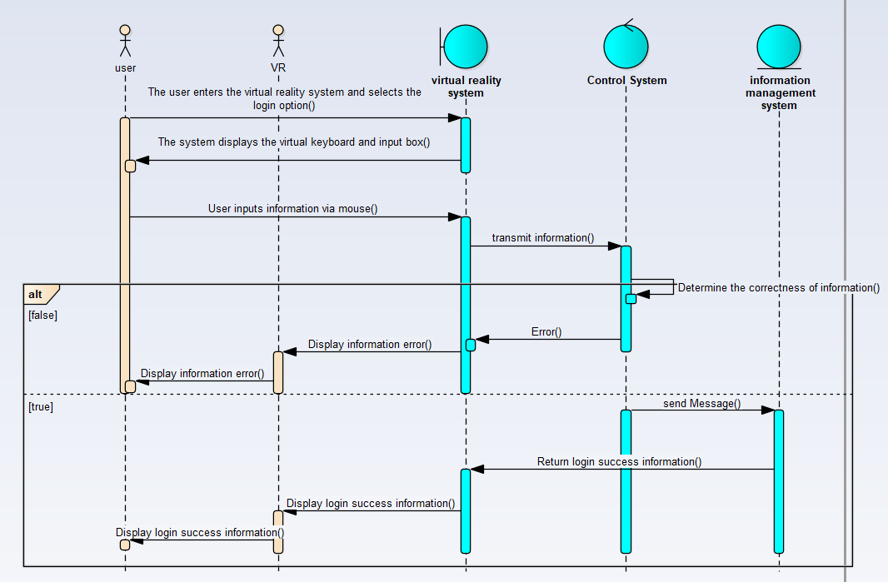

Fig 2

## 4.2 Use Case for User

### 4.2.1 Register a personal account

Use Case: Register a personal account

Participant：User

Brief description：In this use case, users can interact with the information management system through virtual reality devices and create personal information accounts.

Main flow:

1. The user enters the virtual reality system and selects the Create User option.
2. The system displays input boxes, virtual keyboards, and required fields.
3. Users enter personal information through virtual keyboards and gestures.
4. Information management system determines information accuracy.
5. Virtual reality system displays results.

Alternative flow：

4.1 If the information provided is invalid, an appropriate error message will be displayed indicating which fields contain invalid information.

4.2 Users can modify the information and submit again.

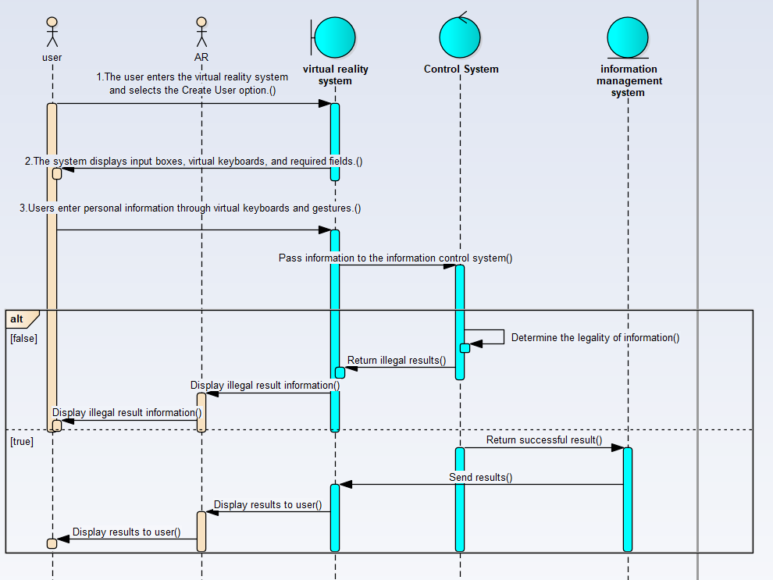

Fig 3

### 4.2.2 View personal information

Use Case: View personal information

Participant：User

Brief description：In this use case, users can view their personal information, including basic personal information, class schedule, grade points, etc.

Main flow:

1. The user enters the system and selects the option to browse per-sonal information.
2. The system displays a virtual interface for personal account infor-mation, including username, contact information, academic records, etc.
3. Users can browse different parts of personal information in the virtual scene, such as clicking on academic records to view grades, clicking on contact information to view contact information, etc.

Fig 4

Alternative flow：

3.1 The user clicks on the academic records section on the virtual interface.

3.2 The system displays detailed information on academic records, including courses taken, grades, etc.

### 4.2.3 Modify personal information

Fig 5

Use Case: Modify personal information

Participants: user, MR

Brief description: This case describes the process of modifying information by users.

Main flow:

1. The user enters the virtual interface
2. The user gets their own information model
3. Use MR technology to offer the way to interact with the user’s information model
4. The user modifies the information

Alternative flow:

4.1 When the user modifies the information illegally, the virtual interface will display an error information.

## 4.3 Use Case for Teacher

### 4.3.1 View students' information

Use Case: View students' information

Participant：Teacher

Brief description：In this use case, teachers can view students’ personal information through the virtual reality system.

Main flow:

1. The teacher enters the virtual reality system and selects the option to view student information.

Fig 6

1. Teachers use the virtual interface and keyboard to select students to view.
2. Virtual reality system displays student information.

Alternative flow:

* 1. If the system does not find the entered student information, it will be displayed to the teacher.
  2. Teachers can enter students again.

## 4.4 Use Case for Administrator

### 4.4.1 Modify user’s information

Fig 7

Use Case: Modify user’s information

Participants: administrator, MR

Brief description: This case describes administrators can modify the information of the user who is in this information system.

Main flow:

1. The administrator enters the virtual interface
2. The administrator input the infor-mation of the user whose information will be changed
3. Use MR technology to offer the way to interact with the user’s information model
4. The administrator modifies the information

Alternative flow:

2.1 When the system controller cannot find the user, it will display an error information in the virtual interface.

### 4.4.2 View people’s information

Use Case: view people’s information

Participant: administrator, AR

Brief description: This use case describes the process that the administrator views the user’s information.

Main flow:

1. The administrator enters the virtual interface.
2. The administrator input the information of the user whose information will be viewed
3. Use AR technology to get the information by scanning the user’s information model

Alternative flow:

* 1. When scanning the model in error, the administrator will receive the reminder information.

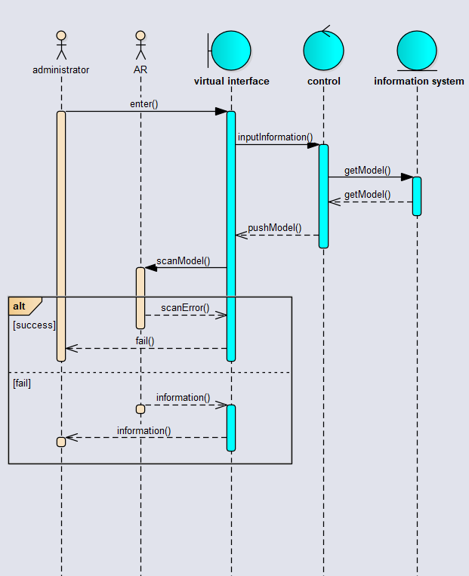

Fig 8

### 4.4.3 Create accounts for users

Use Case: create accounts for users

Participant: administrator, VR

Brief description: This use case describes the process that the administrator creates the account for the user who is applying for an account.

Main flow:

1. The administrator enters the virtual inter-face
2. Use VR technology to create a virtual space for the user to store the information model

Fig 9

1. The administrator stores the account information in the system

Alternative flow:

3.1 When there is no room to store the information in the system, the system will display a warning.

## Ⅴ.LOGICAL VIEW: ARCHITECTURE OVERVIEW

## Class Diagram

The main classes related are as follow, The visitor class and the account class are related relationships, the user class and the visitor class are generalized relations, and the student class, teacher class and user class are generalized relationships,the MR class ,VR class and VR class and XR class are generalized relationships.

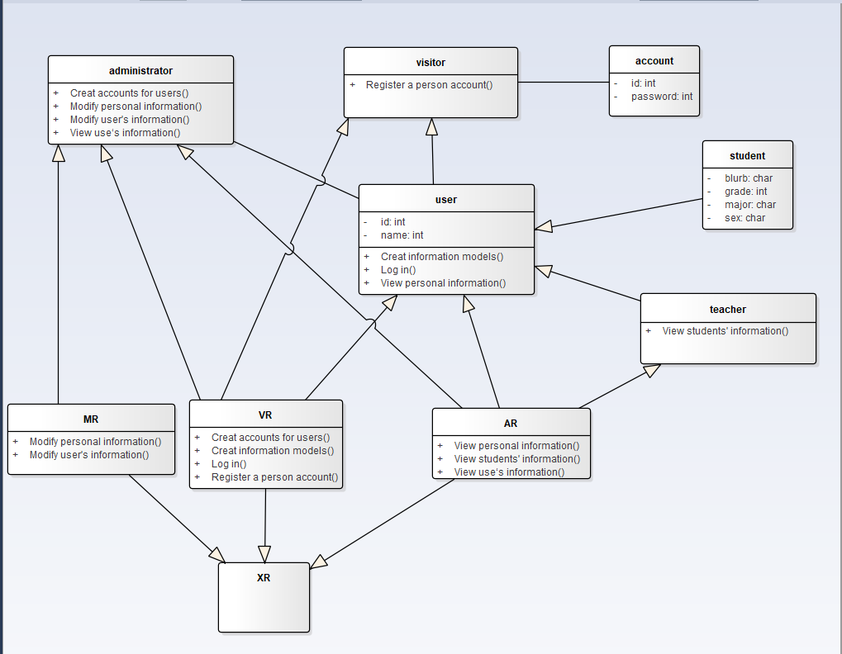

Fig 10

## Database Construction

### Entity Relationship Diagram

**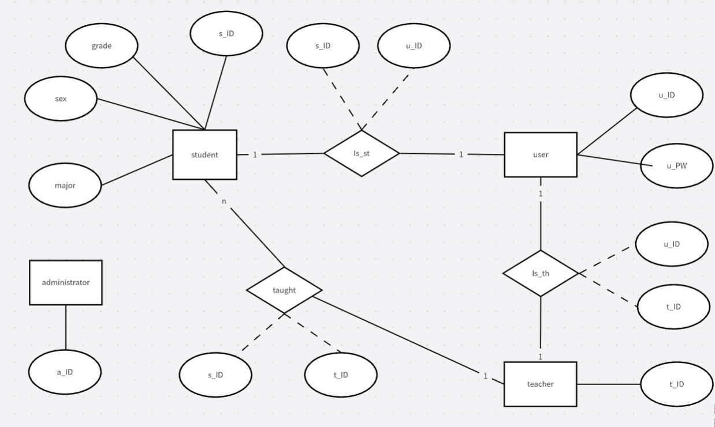**

Fig 11

### Relational schema

student(s\_ID,grade,sex,major)

user(u\_ID,u\_PW)

teacher(t\_ID)

administrator(a\_ID)

Is\_st(s\_ID,u\_ID)

taught(s\_ID,t\_ID)

Is\_th(u\_ID,t\_ID)

## Ⅵ.PROCESS VIEW

## 6.1 Activity Diagram

**Start Node**: The user enters the virtual reality system.

**Decision Node**:

* The user chooses either the login option or the create user option.
* The login system returns the result. If the account password is incorrect, the user needs to re-enter their account password, which is then sent again to the login system for verification.
* The information management system verifies the accuracy of the information.

**Activity**:

* If the user chooses to log in, the system displays a virtual keyboard and input box. The user enters their account and password, and then the virtual reality system sends this information to the login system for verification.
* If the user chooses to create a user, the system displays an input box, virtual keyboard, and required fields. The user inputs their personal information through the virtual keyboard and gestures.
* The virtual reality system displays the result. If the provided information is invalid, the user can modify their information and resubmit it.

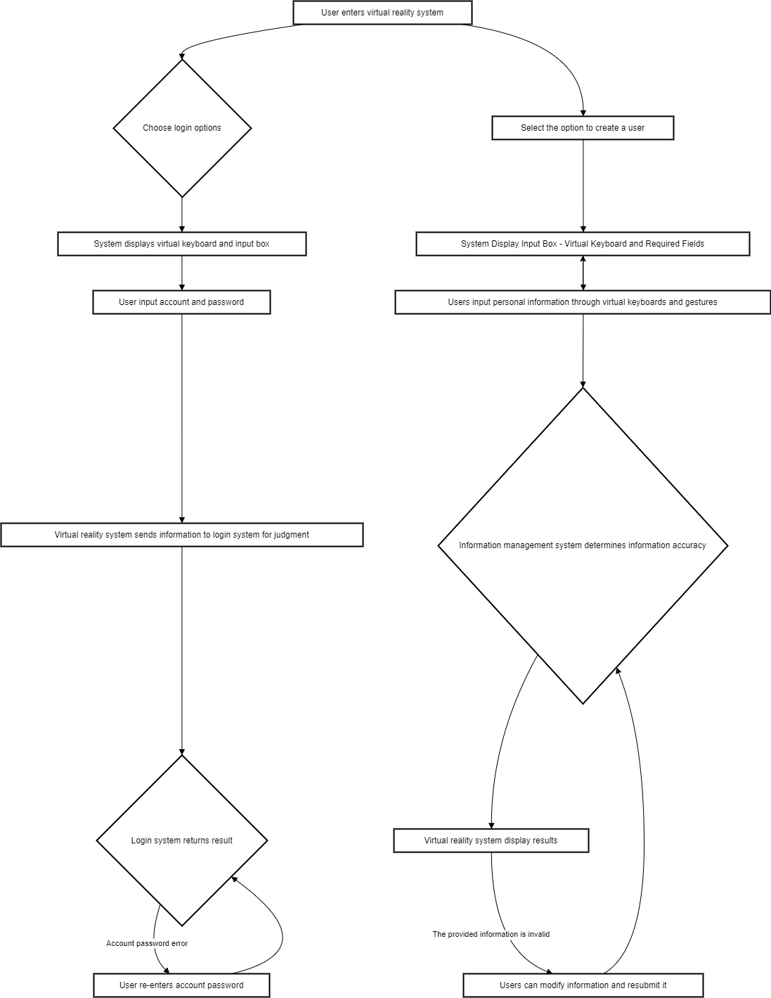

Fig 12

## Ⅷ.DEPLOYMENT VIEW

## 7.1 Deployment Diagram

* **Execution Environments**: These are the environments in which the system operates, including MR, AR, and VR. These environments are connected by lines, indicating that they can exchange data and information with each other.
* **Devices**: This includes a Web server, a DB server, and a MySQL server. These devices are also connected by lines, indicating that they can exchange data and information with each other. The MySQL server is highlighted in pink, which may indicate that it plays an important role in the system.
* **Connections**: The connection lines represent the communication relationships between the execution environments and devices. In this system, all execution environments and devices are interconnected, indicating that data and information can flow freely between them.

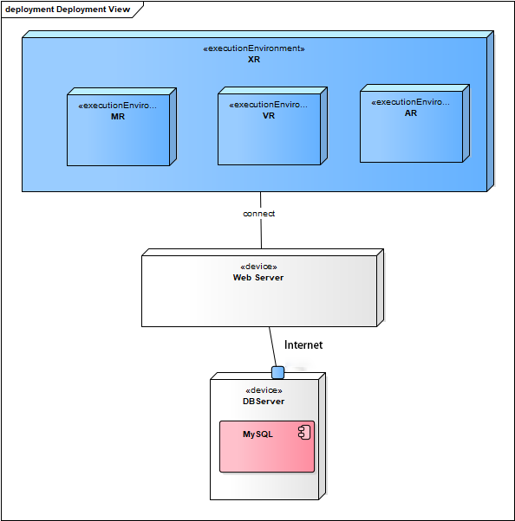

Fig 13

## Ⅸ.PHYSICAL VIEW

## 8.1 Component Diagram

* **Workbench**: This is the main workspace of the system where users can perform various operations.
* **Data Source**: This is where data is stored and managed in the system. In this view, we can see that there are four data sources, which are connected to the workbench and the data source manager respectively.
* **Data Source Management**: This is a special component responsible for managing all data sources. It can add, delete, or modify data sources to meet the needs of the system.

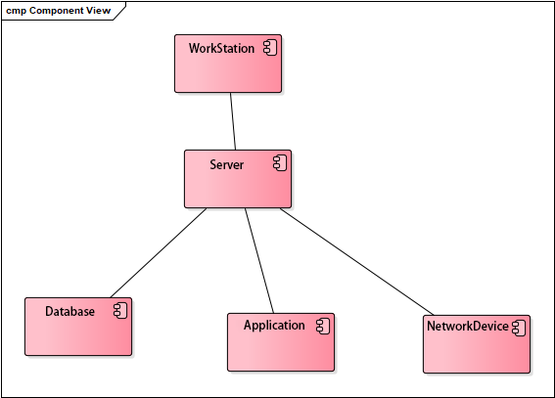

Fig 14

## Ⅹ.REFERENCES

[1] Software engineering—Specification for software development cost measurement:GB/T 36964-2018 (samr.gov.cn)

[2] “XR Technologies and Trends: Pandemic ushers in immersive experiences.” Business Insider Intelligence, April 26, 2021.

[3] Alsop, T., “Extended reality (XR): AR, VR, and MR in the United States, statistics and facts.” Statista, March 22, 2021.

[4] Ding Yi. Design and Implementation of an Information Management System Based on Virtual Reality Technology [J]. Software, 2022,43 (12): 109-111

[5] Sun Ying, Zhou Xinchun. Design of a Purchase Information Management System Based on Virtual Reality Technology [J]. Electronic Production, 2019 (06): 57-58. DOI: 10.16589/j.cnki.cn11-3571/tn.2019.06.023